# Lead Image

## Description

The lead image in the article offers various title placement choices. By default, 'Basic' represents the regular design. Alternately, options like 'center center', 'center left', 'center right', 'bottom left', 'bottom center', and 'bottom right' provide different title placements. When selecting any option other than 'Basic', the article showcases a full-width lead image.

* Title Placement Basic

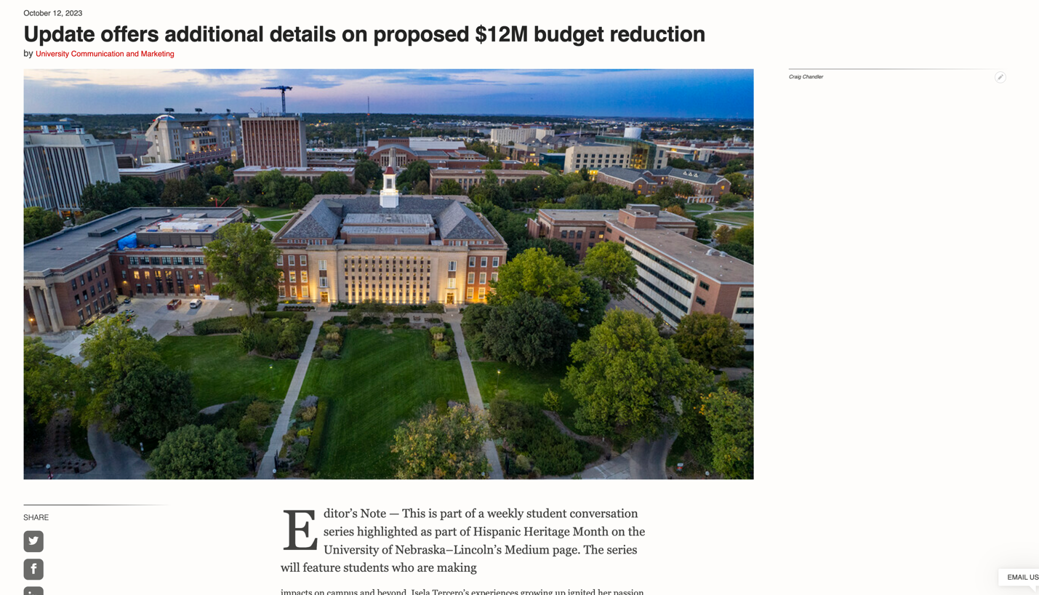

* Title Placement Center Center

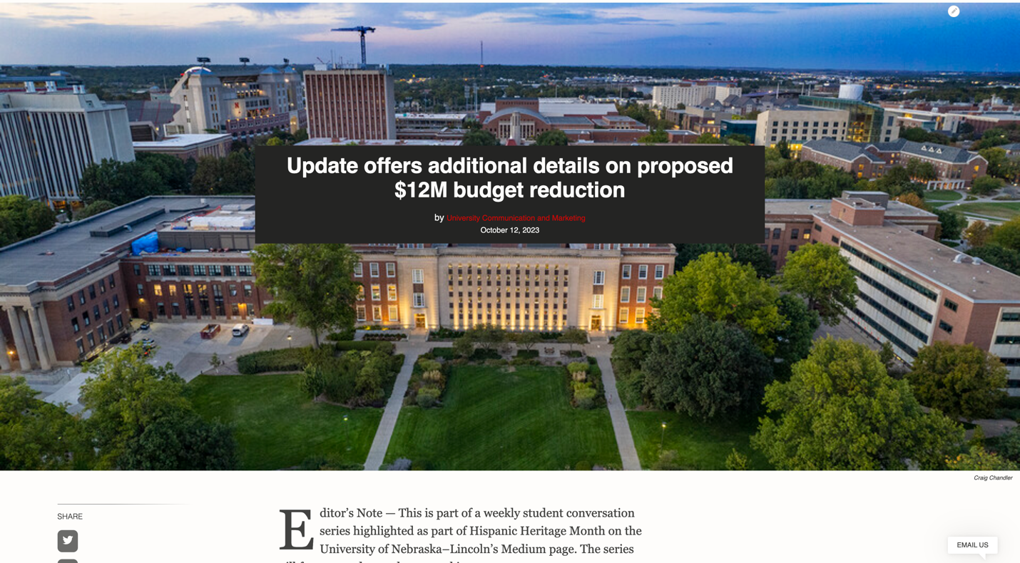

* Title Placement Center Left

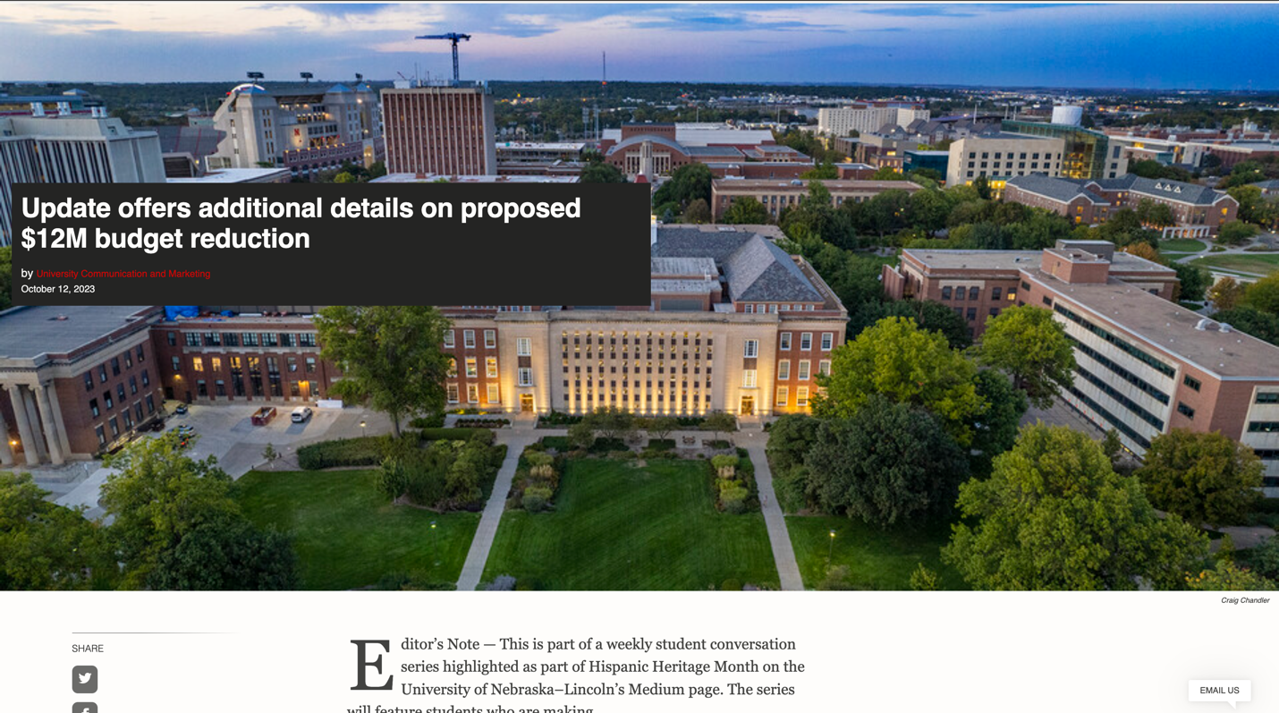

* Title Placement Center Right



* Title Placement Bottom Center

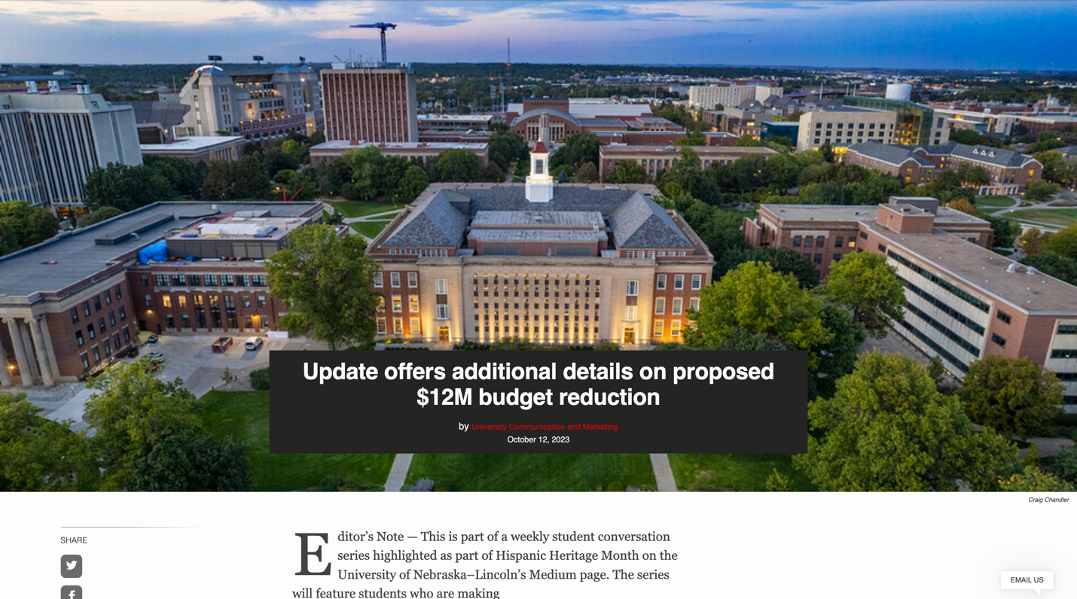

* Title Placement Bottom Left



* Title Placement Bottom Right

